**DELA FUENTE, MARIANNE M. 2ECE-D**

PROBLEM 1

**Tidy Data Frame**

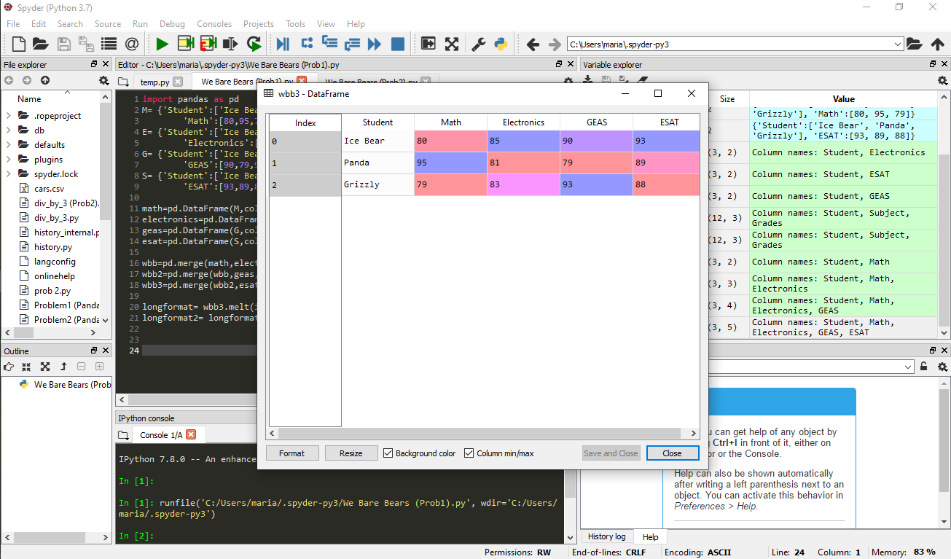



**Long format of the data frame arranged by the name of the student.**

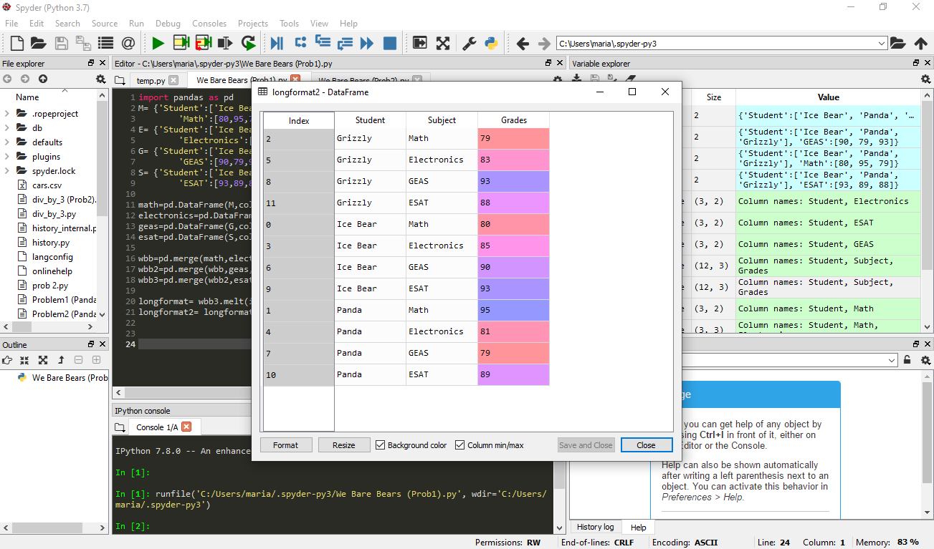



**Long format of the data frame arranged by the index.**

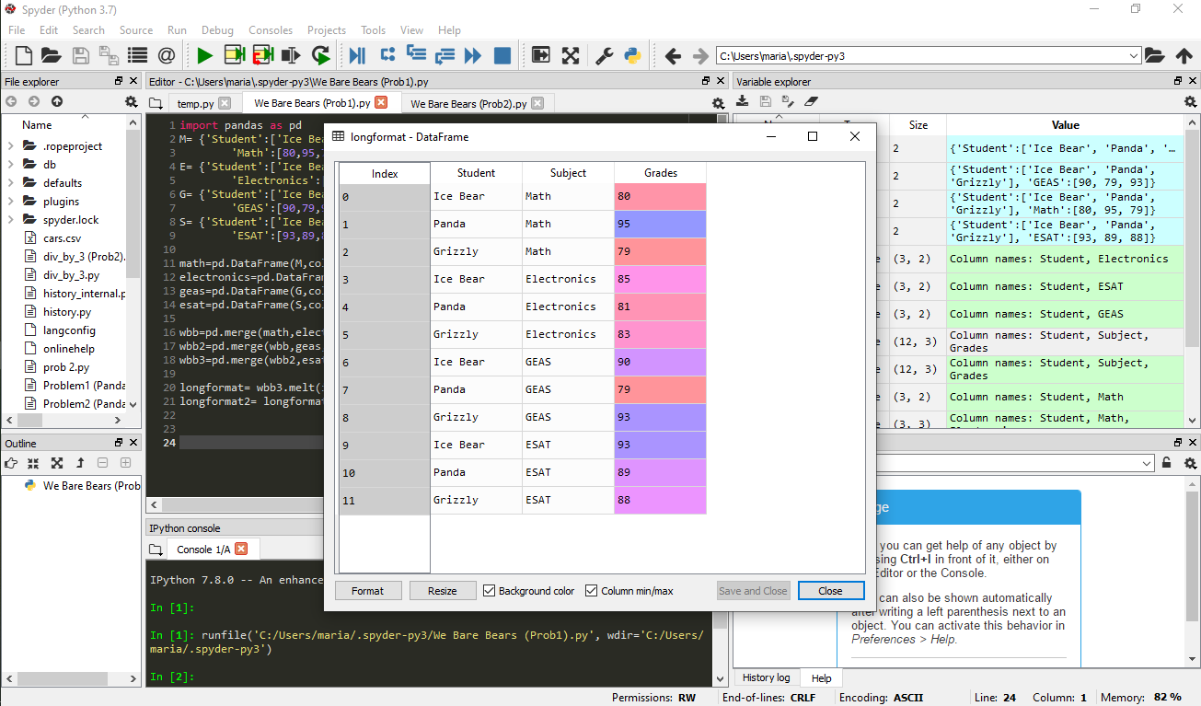



PROBLEM 2

**Tidy data frame**

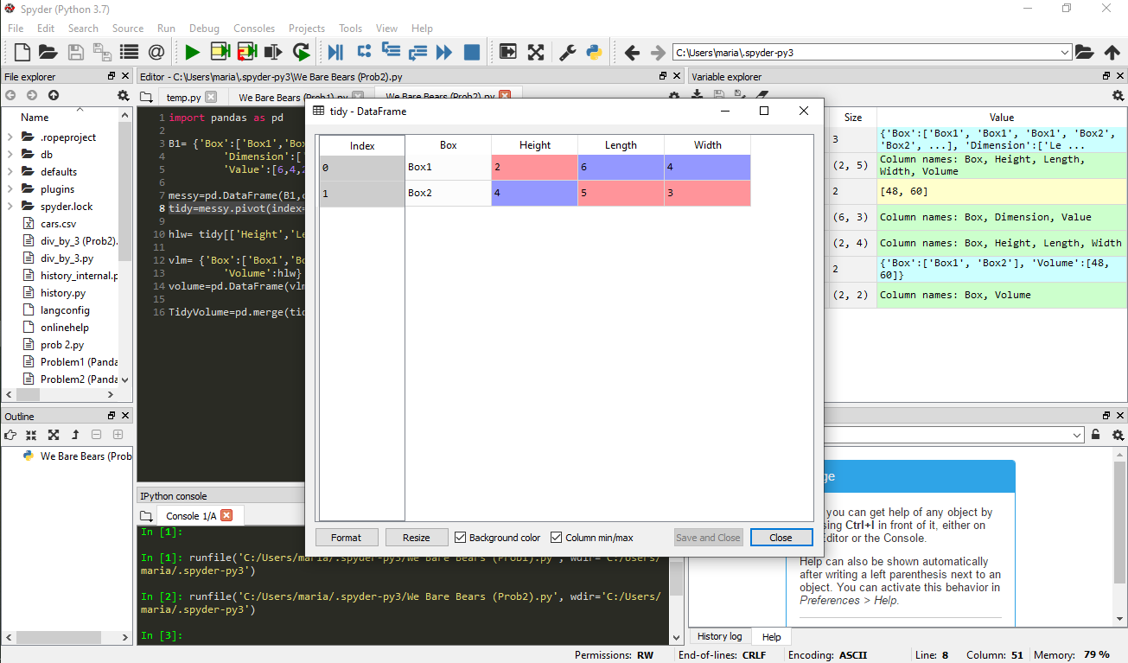

**Data frame of the computed Volume**

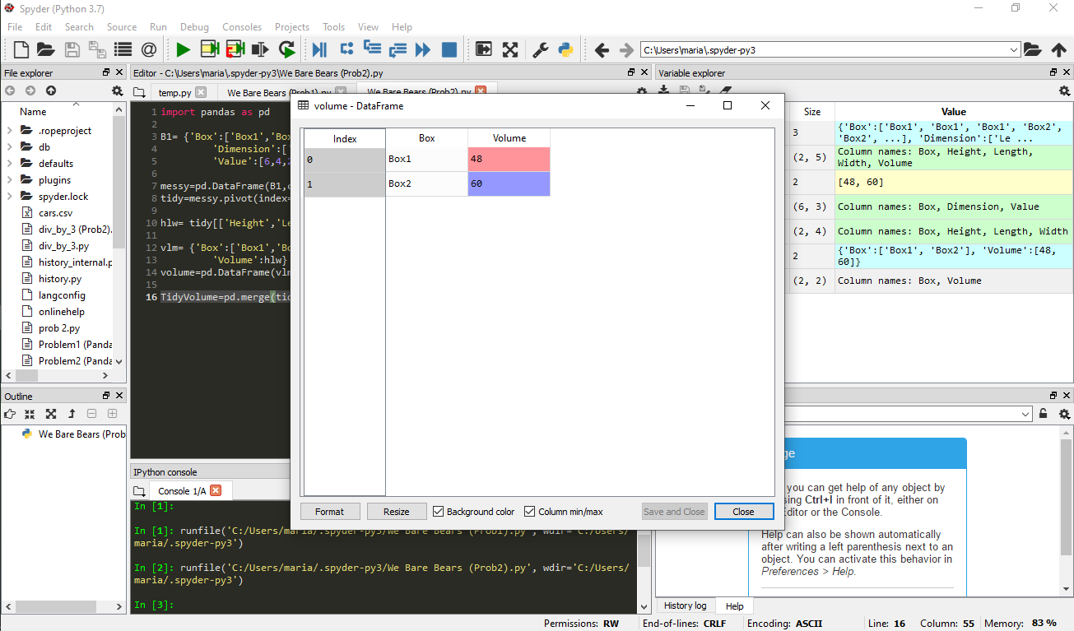

**Data frame of merged tidy and volume data frames**

